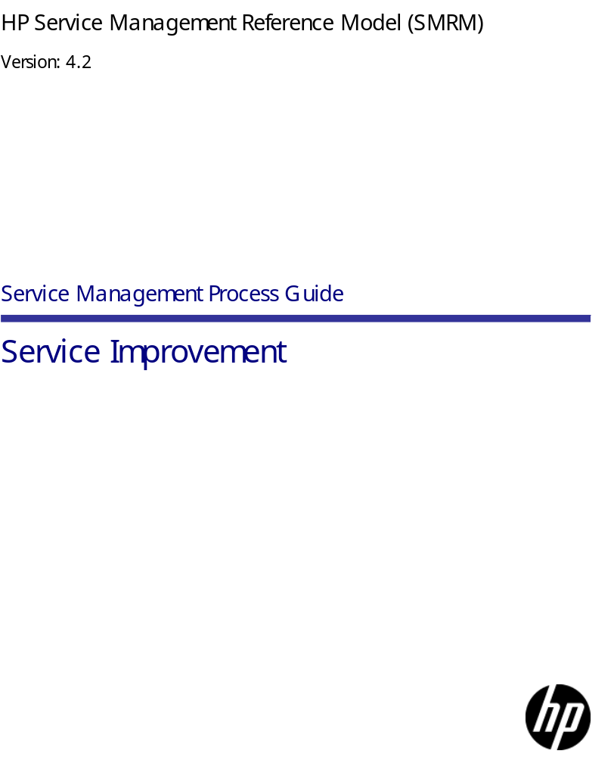

Legal Notices

Warranty
The only warranties for HP products and services are set forth in the express warranty statements accompanying such products and services. Nothing herein should be construed as constituting an additional warranty. HP shall not be liable for technical or editorial errors or omissions contained herein.
The information contained herein is subject to change without notice.

Restricted Rights Legend
HP Confidential. Valid license from HP required for possession, use or copying. Consistent with FAR 12.211 and 12.212, Commercial Computer Software, Computer Software Documentation, and Technical Data for Commercial Items are licensed to the U.S. Government under vendor's standard commercial license.
Copyright Notices
© Copyright 1997–1998, 2003, 2005–2010 Hewlett-Packard Development Company, L.P.

Introduction 4
Service Improvement 5
Business View 7
19 Service Improvement 8
Value to Business 8
Value to IT Organization 8
Basic Concepts 9
In-Scope 9
Out-of-Scope 9
Process Participation in Service Lifecycle 10
Service Improvement Business Principles (Why) 12
SIM – BP1 Produce Quality Services 12
SIM – BP2 Create Value for Stakeholders 12
SIM – BP3 Be an IT Provider of Choice 12
SIM – BP4 Enhance Customer Satisfaction 12
SIM – BP5 Increase Market Share 12
SIM – BP6 Cost Savings 13
SIM – BP7 Comply with Organizational Policies 13
Functional View 14
19 Service Improvement—Diagram 15
Service Improvement Business Goals 16
SIM – BG1 Improvement Recommendations for Services 16
SIM – BG2 Improvement Recommendations for Processes 16
Service Improvement Functional Principles (What) 17
SIM – FP1 Align Improvements with Business Objectives 17
SIM – FP2 Implement Service Improvement Process 17
SIM – FP3 Optimize the IT Infrastructure, Resources and Capabilities 17
SIM – FP4 Continuous Improvement 17
SIM – FP5 Performance Assessment 17
Technical View 18
19 Service Improvement—Diagram 19
19 Service Improvement 20
19.1 Service Improvement - Determine Improvement Opportunities—Diagram 24
19.1 Service Improvement - Determine Improvement Opportunities 25
19.2 Service Improvement - Plan Improvement Activities—Diagram 29
19.2 Service Improvement - Plan Improvement Activities 30
19.3 Service Improvement - Implement Improvement Plan—Diagram 35
19.3 Service Improvement - Implement Improvement Plan 36
19.3.2 Service Improvement - Deploy Improvement Plan—Diagram 37
19.3.2 Service Improvement - Deploy Improvement Plan 38
19.4 Service Improvement - Post Implementation Review—Diagram 41
19.4 Service Improvement - Post Implementation Review 42
Service Improvement Roles—Diagram 44
Service Improvement Roles 45
Service Owner 45
Continual Service Improvement Process Owner 45
Continual Service Improvement Manager 45

Introduction
Service Improvement
This guide defines the Service Improvement (SIM) process. The process is based on the HP Service Management Reference Model, and may have been modified to reflect requirements specific to your organization.
The primary audience for this document is IT Managers, Process Owners and Process Managers responsible for the design, implementation, management, and continuous improvement of this process. This document may also be of interest to IT staff members who execute a specific role within this process and business organizations that want to better understand how the process has been defined within the IT organization.

This process guide has been organized into individual sections, with each section representing a specific view of the process. The Business view, Functional view, and Technical view are included in this document. A fourth view, the Implementation view, is not included. The following information describes each view.

WHY – Business View
The Business View explores the solution from a sponsor’s perspective, and asks the following questions:

- What are the internal and external motivations to change (drivers, goals, and metrics)?
- Who participates in the business processes?
- How is success measured?
- What is the value chain?

WHAT – Functional View
The Functional View explores the solution from the user’s perspective. This view asks the following questions:

- What must the solution do?
- How is it used?
- What services does it provide?
- What is the flow and ownership of information?
- What level of quality is required?

HOW – Technical View
The Technical View defines the solution structure from a constructor’s perspective. This view asks the following questions:

- What are the components?
- What are the interfaces?
- What data are exchanged?
- Which applications are used?
- What level of quality is required?

WITH WHAT – Implementation View

The Implementation View provides justification for implementation from the perspective of an individual responsible for deploying solutions. This view asks the following questions:

- How are solutions tested and accepted?
- How are financials secured?
- How are process and organizational aspects secured?

Note: The Implementation View is not represented in this document.

Goals and Principles
This document describes the goals and principles that support the Service Improvement process.
Goals and principles are identified using the following conventions:

SIM – BG (n): Service Improvement Business Goal
SIM – BP (n): Service Improvement Business Principle
SIM – FP (n): Service Improvement Functional Principle

Business View

19 Service Improvement
The Service Improvement (SIM) process is an integral part of the Continual Service Improvement phase. The SIM process ensures that the services and the processes under the scope of Continual Service Improvement are effective and efficient.

Service Improvement is a process that is designed and implemented to manage improvements to IT services and Service Management processes. The SIM process ensures that there are ongoing improvements to the Service Management system and to the services of both the Business and IT.

The goals of the Service Improvement process are to:
- Identify and recommend improvements to Service Management processes, service quality, effectiveness and efficiency
- Align and re-align IT services to changing business needs by identifying and implementing improvements to IT services that support business processes
- Improve the effectiveness and efficiency of the supporting Service Management system
- Identify and implement activities that improve IT service
- Improve the cost effectiveness of delivering IT services without sacrificing customer satisfaction

The process ensures that the improvements are reflected within the organization with the help of the Managing Organizational Change (MOC) process.
Value to Business
- Improvements to IT services and processes lead to overall improvement of Business processes
- Increases organizational competency
- Integration between People and processes
- Increases Business throughput by reducing redundancies
- Minimizes lost opportunities
- Assures regulatory compliance that minimizes costs and reduces risk
- Ability to rapidly react to change

Value to IT Organization
- Improvement to IT services and processes
- Improvement in performance of IT components
- Better handling of IT-related issues
- Improved utilization of resources

It includes four components:
- Activity: 19.1 SIM - Determine Improvement Opportunities
- Activity: 19.2 SIM - Plan Improvement Activities
- Activity: 19.3 SIM - Implement Improvement Plan
- Activity: 19.4 SIM - Post Implementation Review
Basic Concepts
Service Measurement
Service Measurement includes: setting baselines, monitoring and measuring of the metrics defined for improvement of services and improvement of the underlying Service Management process.

Service Reporting
The Service Measurement and Reporting process is responsible for producing and delivering reports of achievement and trends against Service Levels. Customers should agree to the format, content and frequency of the reports.

Continual Service Improvement Model (CSI)
The Continual Service Improvement model is a series of steps looped to achieve improvements in the service or process. Each step requires information to move to the next level of the model.

7 Step Improvement Process
The seven steps represent the various activities in a Continual Service Improvement model. The steps also include the activities of the Service Measurement and Reporting process.

In-Scope
Activities that are in-scope include:
- Review of service level information and trends
- Review of Service Management processes information and trends
- Review of existing deliverables for relevance
- Conducting external and internal service reviews to identify continual service improvement opportunities
- Make improvement recommendations
- Make ad-hoc recommendations for approval

Out-of-Scope
Activities that are out-of-scope include:
- Defining metrics for measurement (the Service Measurement and Reporting “SMR” process)
- Gathering data (SMR process)
- Defining the Reporting framework (SMR process)
- Processing the data (SMR process)
- Presenting reports (SMR process)

Process Participation in Service Lifecycle
HP Service Management Reference Model (SMRM) is one of the industry best practices utilized in HP's Service Management Services. The HP SMRM functions as a high-level, fully integrated process relationship map designed to help organizations rapidly and effectively apply ITIL V3 guidelines. SMRM is based upon ITIL V3, and has evolved in breadth and depth from HP's extensive experience in utilizing HP best practices within our organization and in delivering ITIL/Service Management solutions to Customers. SMRM also includes processes that will help IT Organizations become ‘Strategic Partner’ with the Business.

The HP SMRM service lifecycle is aligned to ITIL V3 and the five phases of SMRM are:
- Strategy and Governance
- Design and Planning
- Transition and Control
- Operation and Technology
- Continual Service Improvement

The HP SMRM service lifecycle is initiated from a change in requirements in the business.

These requirements are identified and agreed-upon in the “Strategy and Governance” phase based on the desired business outcome and this is defined in the Service Package (SP).

The Service Package goes through the “Design and Planning” phase, where a service solution is produced in a Service Design Package (SDP) containing everything necessary to take this service through the remaining stages of the lifecycle.

The Service Design Package then passes to the “Transition and Control” phase where:
- The service is evaluated, tested, and validated.
- The Service Knowledge Management System (SKMS) is updated.
- The service is transitioned into the live environment, where it enters the “Operation and Technology” phase.

If business circumstances, assumptions or requirements have changed since design, modifications will be required during the “Transition and Control” phase to assure delivery of the required service.

The "Transition and Control" phase delivers services that are required by the business for operational use. The “Operation and Technology” phase delivers all necessary elements required for the ongoing operation and support of that service.

Continual Service Improvement identifies opportunities for the improvement of weaknesses or failures wherever possible within any of these lifecycle stages.

The processes in the “Strategy and Governance” phase are:
- Strategy Generation
- Demand Management
- IT Financial Management
- Service Portfolio Management

The processes in the “Design and Planning” phase are:
- Planning for New or Changed Services
- Service Catalog Management
- Service Level Management
- Capacity Management
- Availability Management
- Service Continuity Management
- Information Security Management
- Supplier Management

The processes in the “Transition and Control” phase are:
- Transition Planning and Support
- Service Validation and Testing
- Release and Deployment Management
- Evaluation
- Change Management
- Knowledge Management
- Service Asset and Configuration Management

The processes in the “Operation and Technology” phase are:
- Operation Management
- Event Management
- Incident Management
- Problem Management
- Request Fulfillment
- Access Management

The processes in the “Continual Service Improvement” phase are:
- Demand Management
- Service Improvement

Service Improvement Business Principles (Why)
The business principles drive the design and operation of the Service Improvement process. These principles should be discussed, agreed-to, and signed-off by the designated Process Owner and management. The principles are guidelines for the subsequent development of process documentation and work instructions.

It includes seven components:
- SIM – BP1 Produce Quality Services
- SIM – BP2 Create Value for Stakeholders
- SIM – BP3 Be an IT Provider of Choice
- SIM – BP4 Enhance Customer Satisfaction
- SIM – BP5 Increase Market Share
- SIM – BP6 Cost Savings
- SIM – BP7 Comply with Organizational Policies

SIM – BP1 Produce Quality Services
The Service Improvement process is responsible for enhancing the quality of the services.

SIM – BP2 Create Value for Stakeholders
Build value for Stakeholders by improving the efficiency of the services delivered.

SIM – BP3 Be an IT Provider of Choice
The IT organization becomes a provider of choice, providing quality services by continually improving processes.

SIM – BP4 Enhance Customer Satisfaction
Improved service quality leads to higher customer satisfaction.

SIM – BP5 Increase Market Share
Service Improvement enhances the capability of providing services at a larger scale.

SIM – BP6 Cost Savings
More efficient service delivery leads to effective cost management.
SIM – BP7 Comply with Organizational Policies
The Service Improvement process assists in complying with the policies and objectives of the organization.

Functional View

19 Service Improvement—Diagram

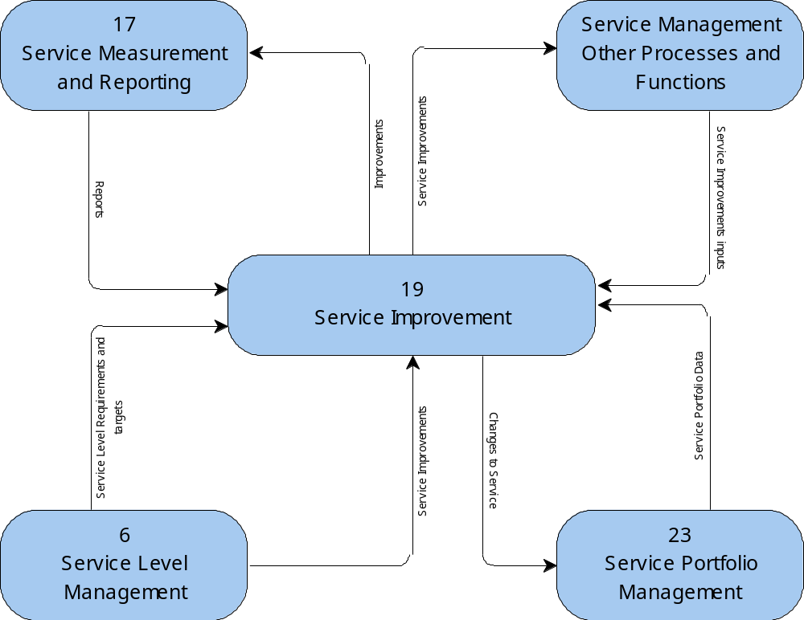
Service Improvement Business Goals
The goal of Service Improvement is to recommend improvements to the Service Management processes and improvements to service quality, effectiveness and efficiency.

It includes two components:
- SIM – BG1 Improvement Recommendations for Services
- SIM – BG2 Improvement Recommendations for Processes

SIM – BG1 Improvement Recommendations for Services
Recommend improvements to service quality, effectiveness and efficiency.

SIM – BG2 Improvement Recommendations for Processes
Recommend improvements to the Service Management processes.

Service Improvement Functional Principles (What)
The functional principles drive the design and operation of the Service Improvement process. These principles should be discussed, agreed-to, and signed-off by the designated Process Owner and management. The principles are guidelines for the subsequent development of Service Improvement process documentation and work instructions.

It includes five components:
- SIM – FP1 Align Improvements with Business Objectives
- SIM – FP2 Implement Service Improvement Process
- SIM – FP3 Optimize the IT Infrastructure, Resources and Capabilities
- SIM – FP4 Continuous Improvement
- SIM – FP5 Performance Assessment

SIM – FP1 Align Improvements with Business Objectives
Service Improvement measures must align with Business goals, mission and vision.

SIM – FP2 Implement Service Improvement Process
Follow a single Service Improvement process for improvements in services and processes.

SIM – FP3 Optimize the IT Infrastructure, Resources and Capabilities
The Service Improvement process optimizes the supporting infrastructure, resources and capabilities.

SIM – FP4 Continuous Improvement
Maintain and regularly communicate an overall quality plan that promotes continuous improvement.

SIM – FP5 Performance Assessment
Periodically review performance against targets, analyze the cause of any deviations, and initiate remedial actions to address the underlying causes. At appropriate times, perform root cause analysis across deviations.

Technical View

19 Service Improvement—Diagram


19 Service Improvement
Name | 19 Service Improvement | Role | Service Management Organization
Description | The Service Improvement (SIM) process is an integral part of the Continual Service Improvement phase. The SIM process ensures that the services and the processes under the scope of Continual Service Improvement are effective and efficient.  Service Improvement is a process that is designed and implemented to manage improvements to the IT services and Service Management processes. The SIM process ensures that there are ongoing improvements to the Service Management system and to the services of both the Business and IT.  The goals of the Service Improvement process are to:  - Identify and recommend improvements to the Service Management processes, Service quality, effectiveness and efficiency  - Align and re-align IT services to changing business needs by identifying and implementing improvements to IT services that support business processes  - Improve the effectiveness and efficiency of the supporting Service Management system  - Identify and implement activities that improve IT service  - Improve cost effectiveness of delivering IT services without sacrificing customer satisfaction  The SIM process ensures that improvements are reflected within the organization with the help of the Managing Organizational Change (MOC) process.  Value to IT:  - Improvement to IT services and processes  - Improvement in performance of IT components  - Better handling of IT-related issues  - Improved utilization of resources

Name | 19.1 SIM - Determine Improvement opportunities | Role | CSI Manager
Description | Based on the input received from various sources, the CSI Manager identifies opportunities for improvement, which can arise in services, processes or the components within services.
Input | - Workflow from Source: Trigger  - Workflow from Activity: 4 Service Asset and Configuration Management  - Workflow from Source: Review Cycle  - Improvements actions & plans from Activity: 5 Change Management  - Improvements actions & plans from Activity: Service Management Other Processes and Functions  - Process Improvement details from Activity: 3 Problem Management  - Report from Activity: 17 Service Measurement and Reporting  - Validated Service Improvements Requirements from Activity: 11 Availability Management  - Improvements actions and plans from Activity: 4 Service Asset and Configuration Management  - Operational Improvements from Source: Trigger  - Scheduled Review from Source: Review Cycle
Output | - Workflow to Activity: 27 Request Fulfillment  - Improvement opportunities to Activity: 19.2 SIM - Plan Improvement activities  - Service Request Raised for Activity: 27 Request Fulfillment

Name | 19.2 SIM - Plan Improvement activities | Role | CSI Manager
Description | In this stage of the process, the Service Improvement Plan (SIP) is created. The CSI Manager considers and explains all the activities to create the SIP.
Input | - Workflow from Activity: 30 Managing Organizational Change  - Improvement opportunities from Activity: 19.1 SIM - Determine Improvement opportunities  - Include MOC plan from Activity: 30 Managing Organizational Change
Output | - Workflow to Sink: End Process  - Workflow to Activity: 30 Managing Organizational Change  - Service Improvement Plan to Activity: 19.3 SIM - Implement Improvement plan  - Service Improvement Plan to Store: Service Knowledge Management System (SKMS)  - Plan for MOC for Activity: 30 Managing Organizational Change

Name | 19.3 SIM - Implement Improvement plan | Role | Service Owner
Description | Implement improvement activities based on the Service Improvement Plan (SIP) that was created earlier. Monitor the SIP implementation and measure its effectiveness.
Input | - Workflow from Activity: 30 Managing Organizational Change  - Change Implemented from Activity: 5 Change Management  - Service Improvement Plan from Activity: 19.2 SIM - Plan Improvement activities  - Implemented MOC plan from Activity: 30 Managing Organizational Change
Output | - Workflow to Activity: 30 Managing Organizational Change  - Implementation Results to Activity: 19.4 SIM - Post Implementation Review  - Raised RFC to Activity: 5 Change Management  - Updated SIP to Store: Service Knowledge Management System (SKMS)  - Implement MOC for Activity: 30 Managing Organizational Change

Name | 19.4 SIM - Post Implementation Review | Role | CSI Manager
Description | The CSI Manager reviews the Service Improvement Plan (SIP) after implementation. Analyze to identify and measure the outcome of SIP activities.
Input | - Implementation Results from Activity: 19.3 SIM - Implement Improvement plan  - Service Improvement Plan from Store: Service Knowledge Management System (SKMS)
Output | - Update SIP to Store: Service Knowledge Management System (SKMS)  - Updated SIP to Sink: End Process

19.1 Service Improvement - Determine Improvement Opportunities—Diagram


19.1 Service Improvement - Determine Improvement Opportunities
Name | 19.1 SIM - Determine Improvement opportunities | Role | CSI Manager
Description | Based on the input received from various sources, the CSI Manager identifies opportunities for improvement, which can arise in services, processes or the components within services.

Name | 19.1.1 SIM - Collate inputs | Role | CSI Manager
Description | The CSI Manager collates the input from the scheduled plan for improvement and operational improvements.
Input | - Workflow from Source: Review Cycle  - Workflow from Activity: 4 Service Asset and Configuration Management  - Workflow from Source: Trigger  - Improvements actions & plans from Activity: Service Management Other Processes and Functions  - Process Improvement details from Activity: 3 Problem Management  - Report from Activity: 17 Service Measurement and Reporting  - Scheduled Review from Source: Review Cycle  - Operational Improvements from Source: Trigger  - Improvements actions and plans from Activity: 4 Service Asset and Configuration Management
Output | - Inputs to Activity: 27 Request Fulfillment based upon a No condition for Decision Point: 19.1.2 SIM - Information Complete & Correct?  - Inputs to Activity: 19.1.3 SIM - Analyze Information based upon a Yes condition for Decision Point: 19.1.2 SIM - Information Complete & Correct?

Name | 19.1.2 SIM - Information Complete & Correct? | Role | CSI Manager
Description | The Continual Service Improvement Manager determines if the information is complete and correct.
Output | - Service Request Raised for Activity: 27 Request Fulfillment

Name | 19.1.3 SIM - Analyze Information | Role | CSI Manager
Description | Once the CSI Manager confirms that the information collated is complete and correct, then the input is further analyzed to create a knowledge base used in decision making. For example: Is the trend analysis supported by proper input? What is level of inefficiency?
Input | - Inputs from Activity: 19.1.1 SIM - Collate inputs based upon a Yes condition for Decision Point: 19.1.2 SIM - Information Complete & Correct?
Output | - Analysis Results to Activity: 19.1.4 SIM - Identify Improvement areas

Name | 19.1.4 SIM - Identify Improvement areas | Role | CSI Manager
Description | Based on the analyzed information, identify improvement areas and opportunities.  Back up the identified areas with proper proof (e.g. metrics and reports).
Input | - Analysis Results from Activity: 19.1.3 SIM - Analyze Information
Output | - Identified Improvement areas to Activity: 19.1.5 SIM - Identify additional improvements

Name | 19.1.5 SIM - Identify additional improvements | Role | Service Owner
Description | The Service Owner identifies any additional improvements required based on the input.
Input | - Identified Improvement areas from Activity: 19.1.4 SIM - Identify Improvement areas
Output | - Identified Improvement areas to Activity: 19.1.6 SIM - Set Improvement targets

Name | 19.1.6 SIM - Set Improvement targets | Role | CSI Manager
Description | Set an achievable target for each improvement area, which is agreed to by all stakeholders. This is the foundation for the planned chain of improvement activities.  In case targets are not achieved, they must be reset after negotiations with respective stakeholders.
Input | - Targets from Activity: 19.1.6 SIM - Set Improvement targets based upon a No condition for Decision Point: 19.1.7 SIM - Targets achievable  - Identified Improvement areas from Activity: 19.1.5 SIM - Identify additional improvements
Output | - Targets to Activity: 19.2 SIM - Plan Improvement activities (in the form of Improvement opportunities) based upon a Yes condition for Decision Point: 19.1.7 SIM - Targets achievable  - Targets to Activity: 19.1.6 SIM - Set Improvement targets based upon a No condition for Decision Point: 19.1.7 SIM - Targets achievable

Name | 19.1.7 SIM - Targets achievable? | Role | Service Owner
Description | The Service Owner determines if the targets set are achievable.  If targets are achievable, then the Service Improvement Plan is created.  If the targets are not achieved, then targets must be reset after negotiations with respective stakeholders.
Input | - Targets from Activity: 19.1.6 SIM - Set Improvement targets
Output | - Decision Point to Activity: 19.1.6 SIM - Set Improvement targets based upon a No condition for Decision Point: 19.1.7 SIM - Targets achievable?  - Decision Point to Improvement Opportunity Activity: 19.2 SIM - Plan Improvement activities (in the form of Improvement opportunities) based upon a Yes condition for Decision Point: 19.1.7 SIM - Targets achievable?

19.2 Service Improvement - Plan Improvement Activities—Diagram

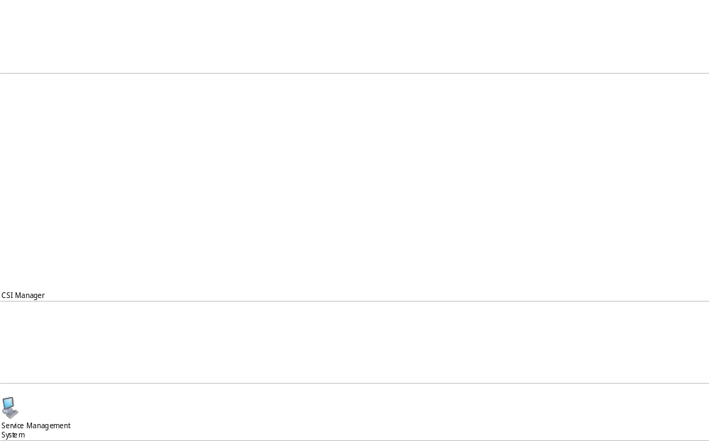
19.2 Service Improvement - Plan Improvement Activities
Name | 19.2 SIM - Plan Improvement activities | Role | CSI Manager
Description | Create the Service Improvement Plan (SIP). Consider and explain all the activities for the creation of the SIP.

Name | 19.2.1 SIM - Prioritize Improvement opportunities | Role | CSI Manager
Description | Consider and prioritize each improvement opportunity for the most efficient handling. It is very important to determine the prioritization based on the criticality or the impact of the improvement area.  Decide the priority based on the following considerations:  - Criticality of the area to be improved  - Negative impact of not implementing the improvement  - Positive impact of implementing the improvement
Input | - Improvement opportunities from Activity: 19.1 SIM - Determine Improvement opportunities
Output | - Workflow to Activity: 30 Managing Organizational Change  - SIP draft to Activity: 19.2.2 SIM - Conduct Analysis  - Plan for MOC for Activity: 30 Managing Organizational Change

Name | 19.2.2 SIM - Conduct Analysis | Role | CSI Manager
Description | Conduct the following analyses before deciding on solution(s):  - Gap Analysis  - Impact Analysis  - Risk Analysis
Input | - SIP draft from Activity: 19.2.1 SIM - Prioritize Improvement opportunities
Output | - SIP draft to Activity: 19.2.3 SIM - Obtain Management Support

Name | 19.2.3 SIM - Obtain Management Support | Role | CSI Manager
Description | Obtaining executive management support ensures the successful implementation of an improvement plan.
Input | - SIP draft from Activity: 19.2.2 SIM - Conduct Analysis
Output | - SIP draft to Activity: 19.2.4 SIM - Assign Owners  - Management go-ahead for Activity: 19.2.4 SIM - Assign Owners

Name | 19.2.4 SIM - Assign Owners | Role | CSI Manager
Description | Assign individual owners for each of the improvement opportunities. Owner accountability facilitates the improvement process, and ensures that efficient solutions are provided.  The owners are responsible for ensuring the correct implementation of improvement activities.
Input | - SIP draft from Activity: 19.2.3 SIM - Obtain Management Support  - Management go-ahead from Activity: 19.2.3 SIM - Obtain Management Support
Output | - SIP draft to Activity: 19.2.5 SIM - Create/Update Individual SIPs

Name | 19.2.5 SIM - Create/Update Individual SIPs | Role | Service Owner
Description | The owners of the improvement areas create individualized Service Improvement Plans (SIPs).  Each SIP includes: multiple solutions, estimated cost of deployment, a schedule, a deployment strategy, and the required resources.  Redesign the improvement plan if approval is not obtained.
Input | - Individual SIPs from Activity: 19.2.6 SIM - Obtain necessary approval based upon a No condition for Decision Point: 19.2.7 SIM - Approval / Acceptance  - SIP draft from Activity: 19.2.4 SIM - Assign Owners  - Rejected from Decision Point: 19.2.7 SIM - Approval / Acceptance
Output | - Individual SIPs to Activity: 19.2.6 SIM - Obtain necessary approval

Name | 19.2.6 SIM - Obtain necessary approval | Role | CSI Manager
Description | Collate the Service Improvement Plans and obtain the necessary approvals.  Approvals may be necessary from: Business executive management (e.g. CEO), IT management (e.g. CIO), Technical Specialists, or Process Owners.
Input | - Individual SIPs from Activity: 19.2.5 SIM - Create/Update Individual SIPs
Output | - Individual SIPs to Activity: 19.2.5 SIM - Create/Update Individual SIPs based upon a No condition for Decision Point: 19.2.7 SIM - Approval / Acceptance  - Individual SIPs to Activity: 19.2.8 SIM - Collate the SIPs based upon a Yes condition for Decision Point: 19.2.7 SIM - Approval / Acceptance  - Individual SIPs to Activity: 19.2.9 SIM - Inform SIP Owners based upon a No condition for Decision Point: 19.2.7 SIM - Approval / Acceptance

Name | 19.2.7 SIM - Approval / Acceptance | Role | CSI Manager
Description | Obtain approval for the Service Improvement Plan(s).
Output | - Rejected for Activity: 19.2.5 SIM - Create/Update Individual SIPs  - Abandonment Recommended for Activity: 19.2.9 SIM - Inform SIP Owners  - Accepted for Activity: 19.2.8 SIM - Collate the SIPs

Name | 19.2.8 SIM - Collate the SIPs | Role | CSI Manager
Description | Collate all approved Service Improvement Plans (SIPs) into a single plan. Create the new Service Improvement Plan. Store the new SIP in the Service Knowledge Management System (SKMS).
Input | - Individual SIPs from Activity: 19.2.6 SIM - Obtain necessary approval based upon a Yes condition for Decision Point: 19.2.7 SIM - Approval / Acceptance  - Workflow from Activity: 30 Managing Organizational Change  - Include MOC plan from Activity: 30 Managing Organizational Change  - Accepted from Decision Point: 19.2.7 SIM - Approval / Acceptance
Output | - Service Improvement Plan to Store: SKMS  - Service Improvement Plan to Activity: 19.3 SIM - Implement Improvement plan

Name | 19.2.9 SIM - Inform SIP Owners | Role | Service Owner
Description | When abandonment of the Service Improvement Plan (SIP) is recommended by the approval team, communicate the reason(s) to the SIP Owners.  It is necessary to set the correct expectation level within the team and among the SIP Owners.
Input | - Individual SIPs from Activity: 19.2.6 SIM - Obtain necessary approval based upon a No condition for Decision Point: 19.2.7 SIM - Approval / Acceptance  - Abandonment Recommended from Decision Point: 19.2.7 SIM - Approval / Acceptance
Output | - Workflow to Sink: End Process

19.3 Service Improvement - Implement Improvement Plan—Diagram

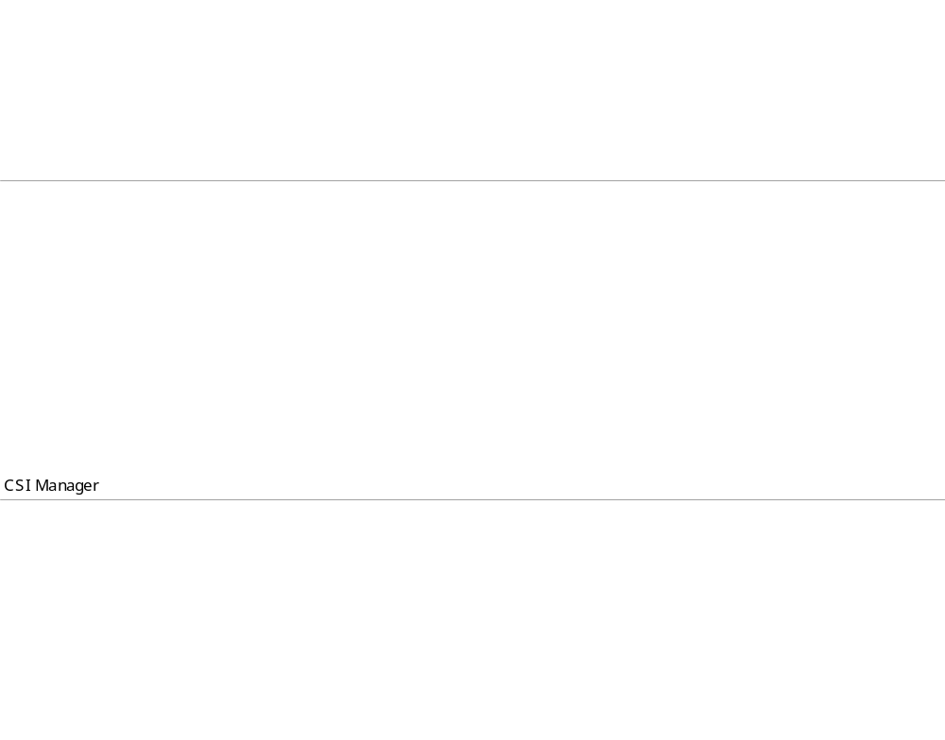
19.3 Service Improvement - Implement Improvement Plan
Name | 19.3 SIM - Implement Improvement Plan | Role | Service Owner
Description | Implement the improvement activities that are based on the SIP created earlier. Monitor the implementation and measure its effectiveness.

Name | 19.3.1 SIM - Publish SIP | Role | CSI Manager
Description | Publish the Service Improvement Plan (SIP) internally to all the stakeholders. This is important for clear communication and ensures acceptance by all stakeholders.
Input | - Service Improvement Plan from Activity: 19.2 SIM - Plan Improvement activities
Output | - Workflow to Activity: 30 Managing Organizational Change  - Service Improvement Plan to Activity: 19.3.2 SIM - Deploy Improvement plan  - Implement MOC for Activity: 30 Managing Organizational Change

Name | 19.3.2 SIM - Deploy Improvement plan | Role | Service Owner
Description | The Service Improvement Plan (SIP) is now ready for deployment.  The implementation includes changes to services, processes and components, therefore the Change Management process will manage the changes.
Input | - Workflow from Activity: 30 Managing Organizational Change  - Change Implemented from Activity: 5 Change Management  - Service Improvement Plan from Activity: 19.3.1 SIM - Publish SIP  - Implemented MOC plan from Activity: 30 Managing Organizational Change
Output | - Implementation Results to Activity: 19.4 SIM - Post Implementation Review  - Raised RFC to Activity: 5 Change Management  - Updated SIP to Store: Service Knowledge Management System (SKMS)

19.3.2 Service Improvement - Deploy Improvement Plan—Diagram


19.3.2 Service Improvement - Deploy Improvement Plan
Name | 19.3.2 SIM - Deploy Improvement plan | Role | Service Owner
Description | The Service Improvement Plan (SIP) is now ready for deployment.  The implementation includes changes to services, processes and components, therefore the Change Management process will manage the changes.

Name | 19.3.2.1 SIM - Review improvement activities | Role | CSI Manager
Description | Review the activities to be implemented during SIP deployment to ensure smooth handling.  If the implementation of the improvement activity fails, the activity must be reviewed and revised.
Input | - Implementation Results from Activity: 19.3.2.4 SIM - Consolidate Implemented results based upon a No condition for Decision Point: 19.3.2.5 SIM - Implement successful?  - Service Improvement Plan from Activity: 19.3.1 SIM - Publish SIP
Output | - Activity details to Activity: 5 Change Management (in the form of Raised RFC) based upon a Yes condition for Decision Point: 19.3.2.2 SIM - Require RFC?  - Activity details to Activity: 19.3.2.3 SIM - Implement Improvement activity based upon a No condition for Decision Point: 19.3.2.2 SIM - Require RFC?

Name | 19.3.2.2 SIM - Require RFC? | Role | CSI Manager
Description | Determine if a Request for Change is required to implement the Change Management process (e.g. activate Change Management when an improvement activity fails).
Input | - Activity details to Decision Point from Activity: 19.3.2.1 SIM - Review improvement activities
Output | - Activity details to Activity: 5 Change Management (in the form of Raised RFC) based upon a Yes condition for Decision Point: 19.3.2.2 SIM - Require RFC?  - Activity details to Activity: 19.3.2.3 SIM - Implement Improvement activity based upon a No condition for Decision Point: 19.3.2.2 SIM - Require RFC?

Name | 19.3.2.3 SIM - Implement Improvement activity | Role | Service Owner
Description | Activities that do not require the Change Management process are implemented within the Service Improvement (SIM) process. Domain specialists might be required in the service improvement implementation.
Input | - Activity details from Activity: 19.3.2.1 SIM - Review improvement activities based upon a No condition for Decision Point: 19.3.2.2 SIM - Require RFC?
Output | - Implementation Results to Activity: 19.3.2.4 SIM - Consolidate Implemented results

Name | 19.3.2.4 SIM - Consolidate Implemented results | Role | CSI Manager
Description | A successful improvement may require implementation of multiple activities. When there are multiple activities, consolidate the activity results and measure its success.
Input | - Workflow from Activity: 30 Managing Organizational Change  - Change Implemented from Activity: 5 Change Management  - Implementation Results from Activity: 19.3.2.3 SIM - Implement Improvement activity  - Implemented MOC plan from Activity: 30 Managing Organizational Change
Output | - Implementation Results to Activity: 19.4 SIM - Post Implementation Review  - Implementation Results to Activity: 19.3.2.1 SIM - Review improvement activities based upon a No condition for Decision Point: 19.3.2.5 SIM - Implement successful?  - Implementation Results to Store: SKMS (in the form of Updated SIP) based upon a Yes condition for Decision Point: 19.3.2.5 SIM - Implement successful?

Name | 19.3.2.5 SIM - Implement successful? | Role | CSI Manager
Description | Determine if the service improvement activity has been successful.
Input | - Implementation results
Output | - Implement Result to successful: Service Improvement Plan to Service Knowledge Management System

19.4 Service Improvement - Post Implementation Review—Diagram

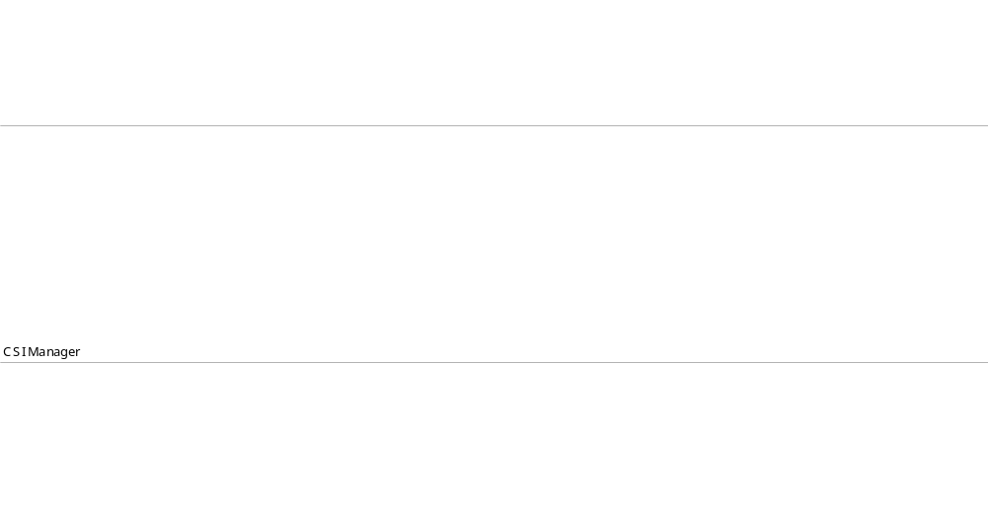
19.4 Service Improvement - Post Implementation Review
Name | 19.4 SIM - Post Implementation Review | Role | CSI Manager
Description | The CSI Manager reviews the Service Improvement Plan (SIP) after its implementation. Analyze and measure the outcome of the SIP activities.

Name | 19.4.1 SIM - Review and analyze | Role | CSI Manager
Description | Review and analyze the results of the improvement activities.
Input | - Implementation Results from Activity: 19.3 SIM - Implement Improvement plan  - Service Improvement Plan from Store: SKMS
Output | - Analysis Results to Activity: 19.4.2 SIM - Measure the outputs

Name | 19.4.2 SIM - Measure the outputs | Role | CSI Manager
Description | Measure the results based on the agreed upon Service Improvement plans.
Input | - Analysis Results from Activity: 19.4.1 SIM - Review and analyze
Output | - Analysis Results to Activity: 19.4.5 SIM - Update SIP and Report based upon a Yes condition for Decision Point: 19.4.3 SIM - Output meeting planned requirements?  - Analysis Results to Activity: 19.4.4 SIM - Take corrective action based upon a No condition for Decision Point: 19.4.3 SIM - Output meeting planned requirements?

Name | 19.4.3 SIM - Output meeting planned requirements? | Role | CSI Manager
Description | Determine if the measured output meets the plan requirements.

Name | 19.4.4 SIM - Take corrective action | Role | Service Owner
Description | If the results do not match the agreed plans, take corrective action(s) to remedy.
Input | - Analysis Results from Activity: 19.4.2 SIM - Measure the outputs based upon a No condition for Decision Point: 19.4.3 SIM - Output meeting planned requirements?
Output | - Workflow to Activity: 19.4.5 SIM - Update SIP and Report  - Corrective Action Status for Activity: 19.4.5 SIM - Update SIP and Report

Name | 19.4.5 SIM - Update SIP and Report | Role | CSI Manager
Description | Update the Service Improvement Plan. Report the update to all stakeholders.
Input | - Analysis Results from Activity: 19.4.2 SIM - Measure the outputs based upon a Yes condition for Decision Point: 19.4.3 SIM - Output meeting planned requirements?  - Workflow from Activity: 19.4.4 SIM - Take corrective action  - Corrective Action Status from Activity: 19.4.4 SIM - Take corrective action
Output | - Update SIP to Store: Service Knowledge Management System (SKMS)  - Updated SIP to Sink: End Process

Service Improvement (SIM) Roles—Diagram


Service Improvement (SIM) Roles
Each process has roles and responsibilities associated with the design, development, execution, and management of the process.

One person can take on multiple roles per requirements specific to the organization. This person may choose to delegate these responsibilities to other roles.

Process accountability remains with the Service Improvement (SIM) Process Owner.

Service Owner
The Service Owner is responsible for the complete service lifecycle, and is the go-to role for all issues regarding service enhancements, service support issues, and obsolescence decisions.

This role can be shared by more than one person based on the number of services and the complexity of the services. To maintain accountability, for one service there can be only one Service Owner.

Service Owner responsibilities:
- Accountable for the overall quality of the service
- Represents the service across the organization
- Ensures accurate information about the services and the Service Catalog is provided to the Service Catalog Management process
- Provides correct relationship information on the services and configuration items in the Service Catalog to the Service Catalog Management process
- Reports any discrepancies in the Service Catalog
- Provides input for Service Catalog Management process improvement

Continual Service Improvement Manager
The CSI Manager is responsible for the success of all improvement activities, and is the single point of accountability for all improvement programs.

CSI Manager responsibilities:
- Responsible for development of the CSI domain
- Responsible for communicating the vision of CSI across the IT organization
- Ensures that CSI roles have been filled
- Works with the Service Owner to identify and prioritize improvement opportunities
- Works with the Service Level Manager to ensure that monitoring requirements are defined
- Works with the Service Level Manager to identify service improvement plans
- Ensures that monitoring tools are in place to gather data

(CSI Manager responsibilities continued)
- Ensures that baseline data is captured to measure improvement against it
- Defines and reports on CSI CSFs, KPIs and CSI activity metrics
- Identifies other frameworks, models and standards that will support CSI activities
- Ensures that Knowledge Management is an integral part of the day-to-day operations
- Ensures that CSI activities are coordinated throughout the service lifecycle
- Presents recommendations to senior management for improvement
- Helps prioritize improvement opportunities
- Leads, manages and delivers cross-functional and cross-divisional improvement projects
- Builds effective relationships with Business and IT senior managers
- Identifies and delivers process improvements in critical business areas across manufacturing and relevant divisions
- Set direction and provide framework through which improvement objectives can be delivered
- Coaches, mentors and supports fellow service improvement professionals
- Possesses the ability to positively influence all levels of management to ensure that service improvement activities are receiving the necessary support and are sufficiently resourced to implement solutions

Continual Service Improvement Process Owner

This key role oversees the Service Improvement process, ensuring that it is followed by the organization.

The CSI Process Owner is accountable as the Champion, Advocate, Design Lead, Coach and Protector of the Service Improvement process. This role manages: the process flows, process documentation and procedures, data models, policies and technologies associated with the Service Improvement process.

CSI Process Owner responsibilities:
- Ensures that the Service Improvement process is defined, documented, maintained and communicated to stakeholders
- Provides input to the ongoing Service Improvement Plan
- Ensures organizational adherence to the Service Improvement process
- Establishes and communicates the process roles and responsibilities
- Ensures adequate process training is available for the organization
- Establishes Key Performance Indicators for process improvement
- Monitors and reports on the performance of the process
- Identifies and communicates opportunities for process improvement
- Manages changes to the Service Improvement process
- Addresses any issues with the running of the process
- Ensures that the Service Improvement process and all the collateral are regularly reviewed and audited
- Establishes tight integration between the Service Improvement process and the Service Measurement and Reporting process

